**Assignment No: - 4**

**Time Series Prediction Using Recurrent Neural Networks (RNNs)**

**Problem Statement:**

Implementing time series prediction using Recurrent Neural Networks (RNNs) for stock market analysis or weather forecasting.

**Objectives:**

1. To implement time series prediction using Recurrent Neural Networks (RNNs) for applications such as stock market analysis or weather forecasting.
2. To understand the architecture and functionality of RNNs in handling sequential data and making predictions based on past information.
3. To explore how RNNs can model temporal dependencies in data for accurate time series forecasting.

**Theory:**

Time series prediction involves forecasting future values based on previously observed data points that are indexed in time order. Examples include predicting stock prices, weather conditions, or demand in a supply chain. Traditional machine learning models may struggle with such tasks because they do not explicitly capture temporal dependencies between consecutive data points.

Recurrent Neural Networks (RNNs) are a class of neural networks specifically designed for processing sequential data. RNNs maintain a hidden state that captures information about previous time steps, allowing them to model dependencies over time. The hidden state is updated at each time step, and the final output is used for prediction.

RNNs, however, may suffer from the vanishing gradient problem, making it difficult to learn long-term dependencies. Variants such as Long Short-Term Memory (LSTM) and Gated Recurrent Units (GRUs) have been introduced to mitigate this issue and are commonly used for time series prediction tasks.

**Methodology:**

1. **Data Collection**:
   * Gather historical time series data relevant to the problem (e.g., stock prices, weather conditions).
   * The data should be properly labeled, cleaned, and organized for training and testing.
2. **Data Preprocessing**:
   * Normalize the data to bring all values within a consistent range (e.g., 0 to 1).
   * Split the dataset into training, validation, and test sets.
   * Prepare input sequences by creating sliding windows of past observations for each time step.
3. **Model Design**:
   * Define an RNN model using layers like LSTM or GRU to handle sequential data.
   * Input: A sequence of time steps.
   * Hidden layers: RNN (or LSTM/GRU) layers that capture temporal dependencies.
   * Output: A predicted value for the next time step in the sequence.
4. **Model Training**:
   * Use a loss function such as mean squared error (MSE) to measure the difference between predicted and actual values.
   * Apply backpropagation through time (BPTT) to train the RNN, updating the weights.
   * Use an optimizer (e.g., Adam) to minimize the loss.
5. **Model Evaluation**:
   * Evaluate the trained model using metrics such as MSE, MAE (Mean Absolute Error), and RMSE (Root Mean Squared Error).
   * Test the model on the validation set to avoid overfitting and ensure it generalizes well to unseen data.
6. **Deployment**:
   * Deploy the model for real-world time series prediction tasks, such as forecasting future stock prices or predicting the weather.

**Working Principle / Algorithm:**

1. **Input Representation**:
   * Prepare the input as a sequence of time steps (e.g., for stock market prediction, a sequence of historical stock prices over the past few days).
2. **Recurrent Computation**:
   * At each time step, the RNN computes an output based on the current input and the hidden state from the previous time step.
   * This hidden state is updated recursively, allowing the RNN to remember previous time steps and capture dependencies.
3. **Prediction**:
   * After processing the entire sequence, the RNN generates a prediction for the next time step.
   * The output could be a single value (e.g., next day’s stock price) or a sequence of future values.
4. **Backpropagation Through Time (BPTT)**:
   * The model is trained using BPTT, where gradients are computed for each time step in the sequence, and weights are updated accordingly.
5. **Final Prediction**:
   * Once trained, the model can predict future values by feeding the current sequence and using its hidden state to predict the next time step.

**Advantages:**

1. **Captures Temporal Dependencies**: RNNs are designed to model sequences and capture dependencies over time, making them ideal for time series data.
2. **Sequential Memory**: Unlike traditional neural networks, RNNs have an internal memory (hidden state) that allows them to retain information from previous time steps.
3. **Adaptability**: RNNs can handle a variety of sequential data types, from stock prices to weather data and natural language sequences.
4. **Versatile Architecture**: Advanced variants such as LSTM and GRU are highly effective in capturing long-term dependencies, solving problems of vanishing gradients.

**Disadvantages / Limitations:**

1. **Vanishing/Exploding Gradient Problem**: Standard RNNs may struggle to learn long-term dependencies due to vanishing or exploding gradients, although this can be addressed with LSTM/GRU.
2. **Training Complexity**: RNNs require more computational resources and longer training times compared to simpler models due to their recursive nature.
3. **Short-Term Focus**: While RNNs can handle sequential data, they may not effectively model very long-term dependencies without advanced architectures like LSTMs.
4. **Data Dependency**: RNN models are sensitive to the quality of the input data, and any noise in the data can significantly affect predictions.

This structured explanation covers the implementation of time series prediction using RNNs, breaking down the objectives, theory, methodology, working principles, advantages, and limitations.

**Diagram:**

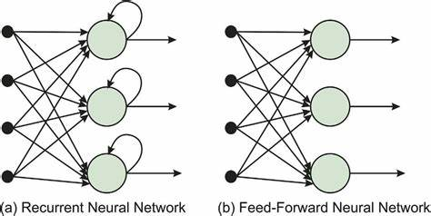 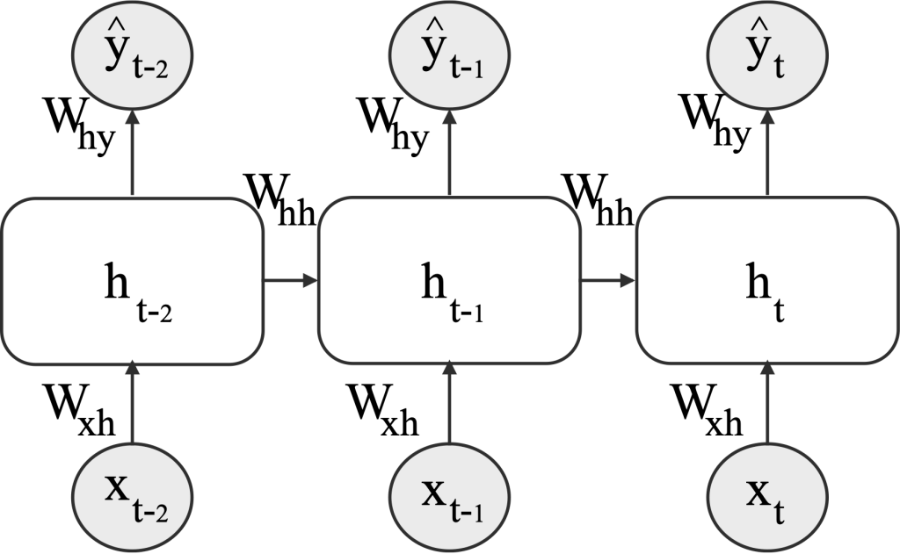

**Conclusion:**

In conclusion, Recurrent Neural Networks (RNNs) provide a powerful approach for time series prediction tasks, effectively capturing temporal patterns in data. Their ability to learn from historical information makes them well-suited for applications like stock market analysis and weather forecasting. While RNNs come with challenges, such as computational demands and the risk of overfitting, their adaptability and effectiveness make them a valuable tool for predictive modeling in various domains. With proper tuning and implementation, RNNs can yield accurate and insightful predictions based on sequential data.